# **Bellco Glass, Inc.**

*Biotechnology Manufacturing*

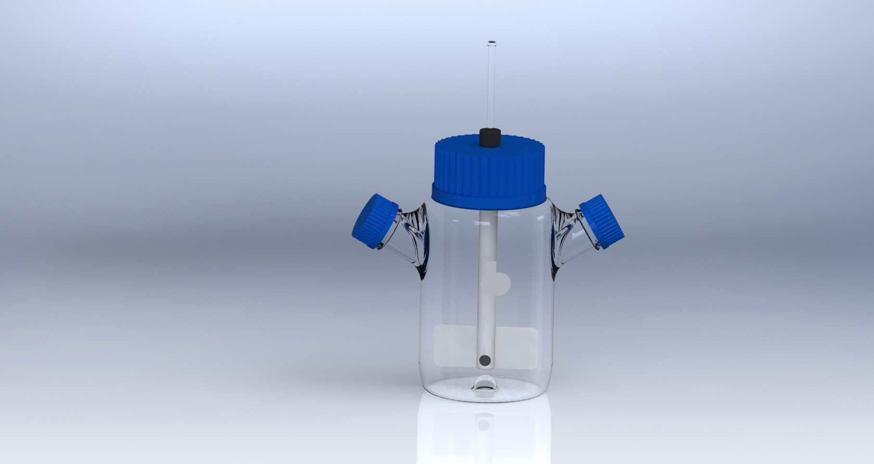

**Micro Carrier Spinner Flask Complete, 1000mL**

SKU : 1965-01000

Micro Carrier Spinner Flasks are designed for the efficient growth of suspension cultures and growth of cells on microcarrier beads

Fluid dynamic impeller assures optimal lift of suspension cultures and microcarrier beads at very low mixing speeds without damage to cultures or beads

Complete consists of spinner flask, impeller assembly, glass shaft, and cap assembly

**Bellco Glass, Inc. services available for products and customers:**

* Technical Support
* Customer Service
* Application Support
* Hardware Support
* Sterilization
* Amber coloring
* Plastic coating

**PRODUCT QUALITY**

Bellco Glass, Inc. guarantees quality in each and every product that goes out the door, from start to finish. With our strict QC policies and procedures, you can safely bet that you will get the best products Bellco Glass, Inc. has to offer with every single order.

**OUR VISION**

We will continue to move forward into the future with quality manufacturing, quality raw materials, and constantly redefining and upgrading our internal processes, thus, making us one of the best biotechnology manufacturing companies in the world.

*Bellco Glass, Inc. presents*

# **Bellco Glass, Inc.**

*Biotechnology Manufacturing*

* **Flask Specifications**:
  + Material: Type 1 Class A Borosilicate Glass
  + Dimensions: 135mm OD x 240mm Overall Height, 265mm across sidearms
  + Two 45mm Sidearms angled 60° offset center
  + One 100mm Screw Thread Center Neck
  + Indented bottom
  + Graduations: 100mL to 1000mL, every 100mL – White Ink (Approx Volumes)
  + Supply with: Two 45mm PP Blue Screw Caps & PP Blue Pouring Rings
* **Impeller Assembly Specifications:**
  + Impeller Assembly consists of impeller magnet, magnet holder, paddle & silicone plug.
  + Impeller magnet: PTFE coated magnet, 76.2mm long x 12.7mm OD (approx.)
  + Magnet Holder: White Teflon, 177.8mm long x 19.1mm OD
  + Impeller Paddle: PTFE material, 107.6mm wide x 44.5mm tall x .762mm thick
  + Silicone Plug: White Silicone material, 11.1mm OD x 7.9mm long (approx.)
* **Glass Shaft Specifications**:
  + Material: Type 1 Class A Borosilicate Glass
  + Dimensions: 7mm OD x 230mm long
* **Cap Assembly Specifications**:
  + Cap Assembly consists of screw cap, liner & compression fitting.
  + 100mm PP Screw Blue Cap: 107.9mm OD x 22.2mm tall with 16.3mm hole for Compression Fitting
  + 100mm White Silicone Liner: 96.8mm OD x 3.2mm thick with 15.9mm hole for Compression Fitting
  + Compression Fitting: Black PP 6.4mm Compression fitting to accept 7mm OD Glass Shaft

**TECHNICAL SUPPORT**

Technical support is available to all of our customers from inquiry to purchase and through the use of the product. Our service department is dedicated to ensuring the best white glove service to you as possible and to providing quality inspection and review of your concerns, should they arise.

**CUSTOMIZATION**

A lot of items that come out of Bellco Glass, Inc. go through a customization process. A customer will come to us with a specific need. Our engineering department will review the item and its capabilities to do whatever we can to create a custom item to perform exactly how you need it to. Contact us today for your customized quote.

**QUALITY GLASS**

Our manufacturing facility uses Type 1 Class A borosilicate glass. This is a type of glass that is of superior thermal and chemical resistance and specifically designed for volumetric glassware, providing you with products that give you longevity of use.

**Specifications**

*\*DISCLAIMER :The information contained in this specification sheet is correct to the best of our knowledge. The recommendations and suggestions therein are made without guarantee or representation as to the results. We recommend that adequate tests be made in your laboratory or plant to determine if this product meets all of your requirements.*