# **Bellco Glass, Inc.**

*Equipment and Glassware Manufacturing*

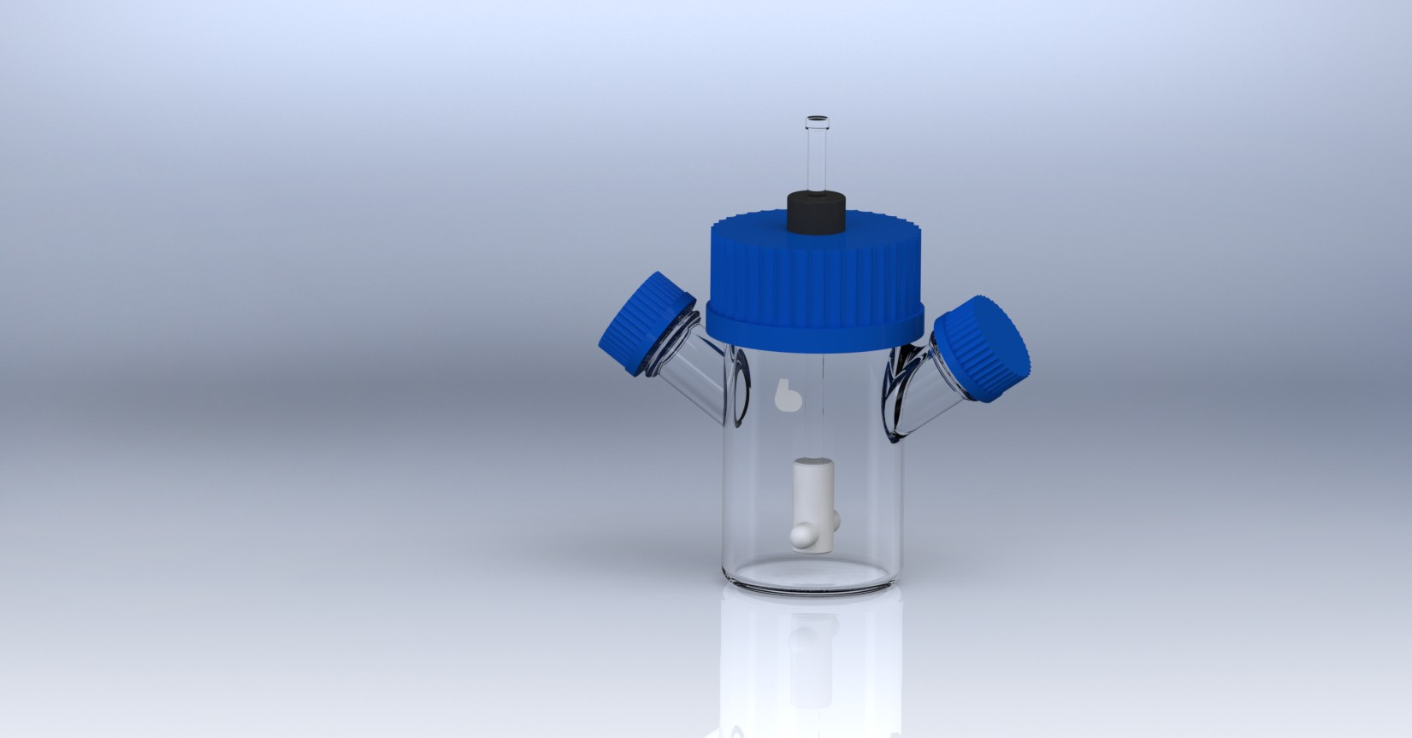

* Designed for the efficient growth of suspension cells at low speeds
* Flask Specifications:
  + 100 mL flat bottom, Type 1 Class A Borosilicate
  + Dimensions: 63.5mm OD x 135mm OAH
  + Two 32mm Sidearms angled 55º offset center
  + One 70mm Screw thread center neck
  + Graduations: 20mL to 100mL, every 20mL
  + Includes two 32mm blue PP screw caps and pouring rings
* Impeller Assembly Specifications:
  + Consists of PTFE coated magnet and white Teflon magnet holder
* Glass Shaft Specifications:
  + Type 1 Class A Borosilicate
  + Dimensions: 7mm OD x 155mm long
* Cap Assembly Specifications:
  + Consists of one 70mm blue PP screw cap with 16.2 mm hole for black compression fitting, 70mm white silicone liner with 15.8mm hole, 7mm black compression fitting

*\*DISCLAIMER :The information contained in this specification sheet is correct to the best of our knowledge. The recommendations and suggestions therein are made without guarantee or representation as to the results. We recommend that adequate tests be made in your laboratory or plant to determine if this product meets all of your requirements.*

**Bellco Glass, Inc. services available for products and customers:**

* Technical Support
* Customer Service
* Application Support
* Hardware Support

**ABOUT OUR GLASS ITEMS**

Our manufacturing facility uses Type 1 Class A borosilicate glass. This is a type of glass that is of superior thermal and chemical resistance and specifically designed for volumetric glassware, providing you with products that give you longevity of use.

**TECHNICAL SUPPORT**

Technical support is available to all of our customers from inquiry to purchase and through the use of the product. Our service department is dedicated to ensuring the best white glove service to you as possible and to providing quality inspection and review of your concerns, should they arise.

**Adjustable Hanging Bar Spinner Flask, Complete 100mL**

SKU : 1967-00100

**PRODUCT QUALITY**

Bellco Glass, Inc. guarantees quality in each and every product that goes out the door, from start to finish. With our strict QC policies and procedures, you can safely bet that you will get the best products Bellco Glass, Inc. has to offer with every single order.

**OUR VISION**

We will continue to move forward into the future with quality manufacturing, quality raw materials, and constantly redefining and upgrading our internal processes, thus, making us one of the best biotechnology manufacturing companies in the world.

*Bellco Glass, Inc. presents*