# **Bellco Glass, Inc.**

*Equipment and Glassware Manufacturing*

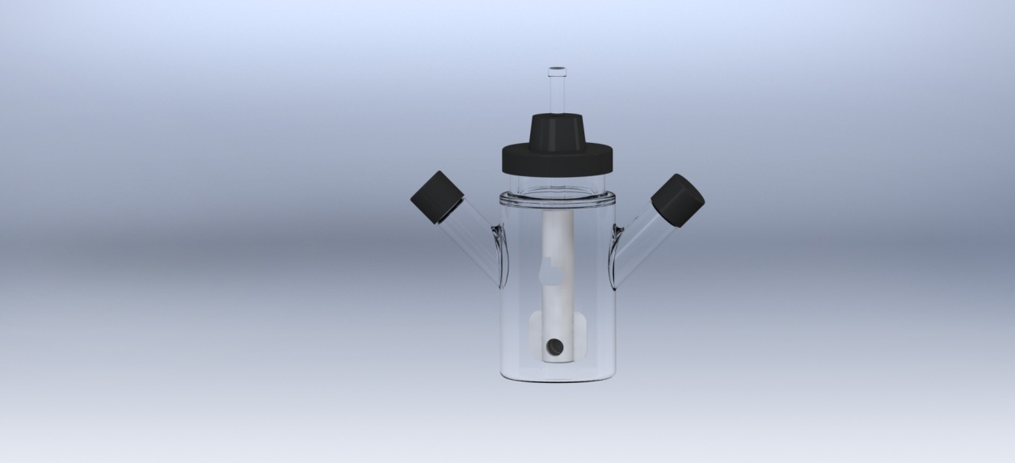

* + Designed for the efficient growth of suspension cultures or cells on microcarrier beads
  + Fluid dynamic impeller assembly assure optimal lift of suspension cells or microcarrier beads at very low mixing speeds without damage
  + Complete includes: flask, impeller assembly, glass shaft, and cap assembly
  + Flask specifications:
    - Type 1 Class A Borosilicate Glass
    - 57mm OD x 110mm OAH, 141mm across side arms
    - Two 18mm side arms angled 45º offset center, one 51mm center screw neck
    - Graduations: 10mL to 50mL every 10mL
    - Supplied with two 18-415 rubber lined black phenolic caps
  + Impeller assembly specifications
    - PTFE coated alnico magnet, 41.3mm OAL x 9.5mm OD approx.
    - Teflon magnet holder, 76.2mm OAL x 15.9mm OD
    - PTFE impeller paddle: 29.4mm wide x 25.4mm tall x0.8mm thick
    - While silicone plug, 11.1mm OD x 7.9mm thick

*\*DISCLAIMER :The information contained in this specification sheet is correct to the best of our knowledge. The recommendations and suggestions therein are made without guarantee or representation as to the results. We recommend that adequate tests be made in your laboratory or plant to determine if this product meets all of your requirements.*

**Bellco Glass, Inc. services available for products and customers:**

* Technical Support
* Customer Service
* Application Support
* Hardware Support

**ABOUT OUR GLASS ITEMS**

Our manufacturing facility uses Type 1 Class A borosilicate glass. This is a type of glass that is of superior thermal and chemical resistance and specifically designed for volumetric glassware, providing you with products that give you longevity of use.

**TECHNICAL SUPPORT**

Technical support is available to all of our customers from inquiry to purchase and through the use of the product. Our service department is dedicated to ensuring the best white glove service to you as possible and to providing quality inspection and review of your concerns, should they arise.

**Micro Carrier Spinner Flask Complete, 50mL**

SKU : 1967-S0030

**PRODUCT QUALITY**

Bellco Glass, Inc. guarantees quality in each and every product that goes out the door, from start to finish. With our strict QC policies and procedures, you can safely bet that you will get the best products Bellco Glass, Inc. has to offer with every single order.

**OUR VISION**

We will continue to move forward into the future with quality manufacturing, quality raw materials, and constantly redefining and upgrading our internal processes, thus, making us one of the best biotechnology manufacturing companies in the world.

*Bellco Glass, Inc. presents*