# **Bellco Glass, Inc.**

*Equipment and Glassware Manufacturing*

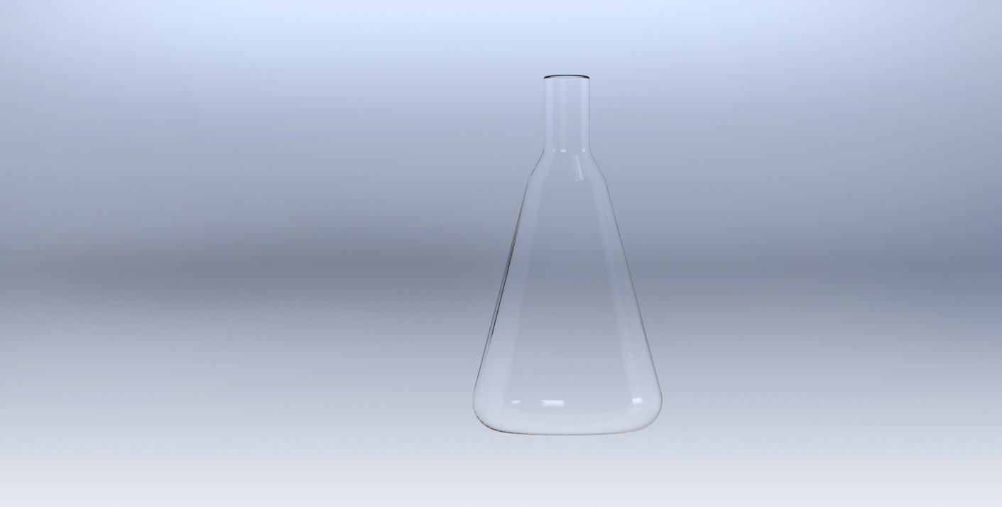

* Material: Type 1 Class A Borosilicate Glass
* Dimensions: 158mm OD x 295mm OAH, 38mm closure
* Graduated to approximate volumes
* Case quantity: 3
* Stainless Steel or KAP-UTS™ disposable closures available for purchase

*\*DISCLAIMER :The information contained in this specification sheet is correct to the best of our knowledge. The recommendations and suggestions therein are made without guarantee or representation as to the results. We recommend that adequate tests be made in your laboratory or plant to determine if this product meets all of your requirements.*

**DeLong® Flask Only, 2000mL**

SKU : 2511-02000

**Bellco Glass, Inc. services available for products and customers:**

* Technical Support
* Customer Service
* Application Support
* Hardware Support

**ABOUT OUR GLASS ITEMS**

Our manufacturing facility uses Type 1 Class A borosilicate glass. This is a type of glass that is of superior thermal and chemical resistance and specifically designed for volumetric glassware, providing you with products that give you longevity of use.

**TECHNICAL SUPPORT**

Technical support is available to all of our customers from inquiry to purchase and through the use of the product. Our service department is dedicated to ensuring the best white glove service to you as possible and to providing quality inspection and review of your concerns, should they arise.

**PRODUCT QUALITY**

Bellco Glass, Inc. guarantees quality in each and every product that goes out the door, from start to finish. With our strict QC policies and procedures, you can safely bet that you will get the best products Bellco Glass, Inc. has to offer with every single order.

**OUR VISION**

We will continue to move forward into the future with quality manufacturing, quality raw materials, and constantly redefining and upgrading our internal processes, thus, making us one of the best biotechnology manufacturing companies in the world.

*Bellco Glass, Inc. presents*