# **Bellco Glass, Inc.**

*Biotechnology Manufacturing*

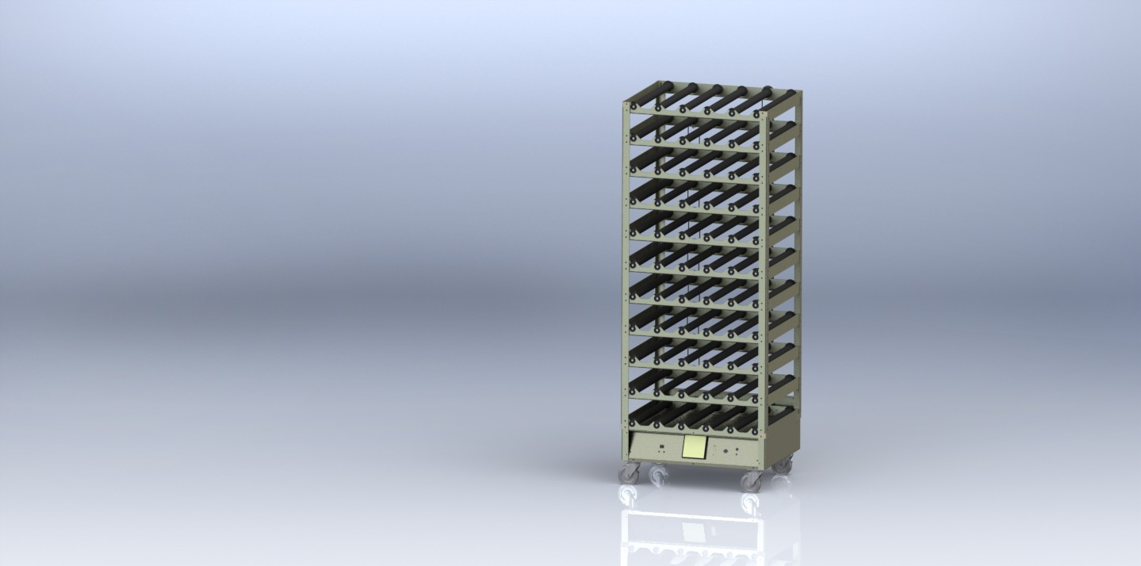

* Bellco Roller Apparatuses are ideal for applications such as the production of mammalian cells, viruses, and cell products
* Rollers have a key design to eliminate slipping and are easily removable for servicing of bearings, easy remove tool included
* Modular configuration allows for up to a total of 11 racks to be installed with ease
* Roller Apparatuses are fitted to a range of incubators to fulfill a variety of lab processes
* Complies with CE safety standards

**Bellco Glass, Inc. services available for products and customers:**

* Technical Support
* Customer Service
* Application Support
* Hardware Support
* Sterilization
* Amber coloring
* Plastic coating

Features a solid state control with heavy duty DC motor and a touch screen display with easy to use interface

The use of a brushless motor with controller ensures smooth operation and no maintenance

Integrated remote monitoring of speed and alarm statuses

All position drive included

**PRODUCT QUALITY**

Bellco Glass, Inc. guarantees quality in each and every product that goes out the door, from start to finish. With our strict QC policies and procedures, you can safely bet that you will get the best products Bellco Glass, Inc. has to offer with every single order.

**OUR VISION**

We will continue to move forward into the future with quality manufacturing, quality raw materials, and constantly redefining and upgrading our internal processes, thus, making us one of the best biotechnology manufacturing companies in the world.

*Bellco Glass, Inc. presents*

**Digital R/A Base & 10 Decks, 115V**

SKU: 7631-S0002

# **Bellco Glass, Inc.**

*Biotechnology Manufacturing*

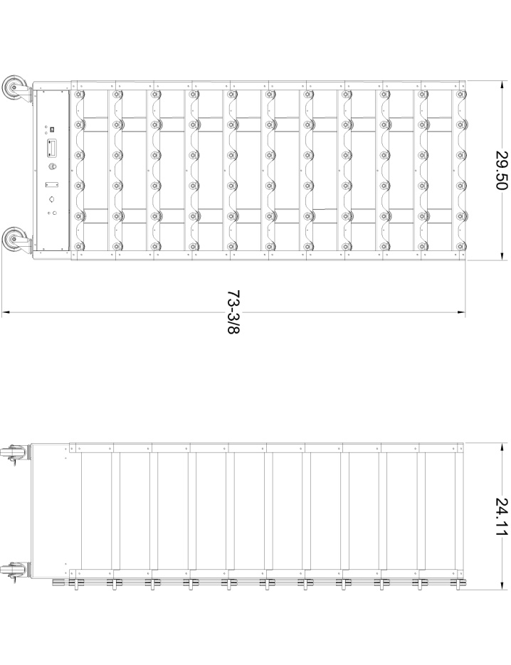

*\*DISCLAIMER :The information contained in this specification sheet is correct to the best of our knowledge. The recommendations and suggestions therein are made without guarantee or representation as to the results. We recommend that adequate tests be made in your laboratory or plant to determine if this product meets all of your requirements.*

* 115 +/- 10VAC @ 60 Hz line voltage
* 3 Amp @ 115V, 60 Hz power consumption
* Dimensions: 29.5″w x 24.11″d x 73-3/8″h (74.9 x 61.2 x 186.4 cm)
* Number of positions: 55
* Bottle Speed: 0.3 to 9.0 RPM
* Roller Construction: Non-transferring chemical resistant rubber rollers with key shape
* Deck to deck clearance: 6” (153mm)
* Usable Roller Length: 51 cm (20”)
* Construction Material: Aluminum, chemically treated enamel finish
* Bottle Size: Accepts Bellco Glass or Plastic Roller Bottles 110mm to 120mm OD up to 510mm in length

**TECHNICAL SUPPORT**

Technical support is available to all of our customers from inquiry to purchase and through the use of the product. Our service department is dedicated to ensuring the best white glove service to you as possible and to providing quality inspection and review of your concerns, should they arise.

**CUSTOMIZATION**

A lot of items that come out of Bellco Glass, Inc. go through a customization process. A customer will come to us with a specific need. Our engineering department will review the item and its capabilities to do whatever we can to create a custom item to perform exactly how you need it to. Contact us today for your customized quote.

**QUALITY GLASS**

Our manufacturing facility uses Type 1 Class A borosilicate glass. This is a type of glass that is of superior thermal and chemical resistance and specifically designed for volumetric glassware, providing you with products that give you longevity of use.

**Specifications**