# **Bellco Glass, Inc.**

*Biotechnology Manufacturing*

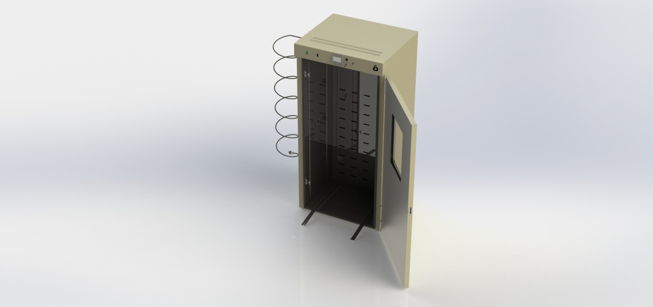

**40 CuFt Roll In CO2 Incubator, 115V**

SKU: 7728-00115

**Bellco Glass, Inc. services available for products and customers:**

* Technical Support
* Customer Service
* Application Support
* Hardware Support
* Sterilization
* Amber coloring
* Plastic coating
* Bellco Incubators have fold out ramps for use with Bellco Roller Apparatus
* 4 interior outlets provide convenience in powering internally placed appliances
* A touchscreen PID temperature controller allows simple setting and monitoring of chamber temperature
* Single Thermal Pane Window for viewing
* Forced air circulation facilitates even temperature distribution throughout the chamber

Fits up to an 11 deck modular Roller Apparatus

Uses infrared sensors to maintain a CO2 concentration range of 0-20%

Each unit includes shelf tracks so that optional stainless steel shelves can be installed

Control panel includes a USB port as well as a 4-20 mA jack for easy data logging of both temperature and CO2 levels

Includes a dry contact alarm port for remote monitoring of alarm status

**PRODUCT QUALITY**

Bellco Glass, Inc. guarantees quality in each and every product that goes out the door, from start to finish. With our strict QC policies and procedures, you can safely bet that you will get the best products Bellco Glass, Inc. has to offer with every single order.

**OUR VISION**

We will continue to move forward into the future with quality manufacturing, quality raw materials, and constantly redefining and upgrading our internal processes, thus, making us one of the best biotechnology manufacturing companies in the world.

*Bellco Glass, Inc. presents*

# **Bellco Glass, Inc.**

*Biotechnology Manufacturing*

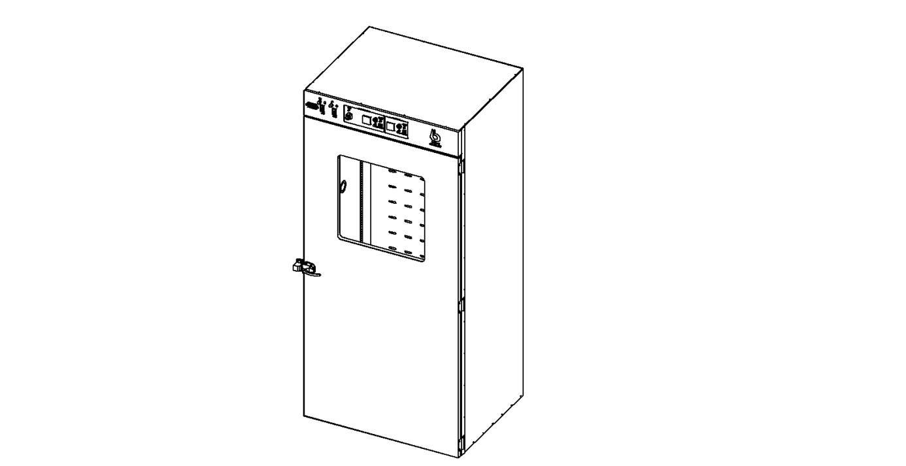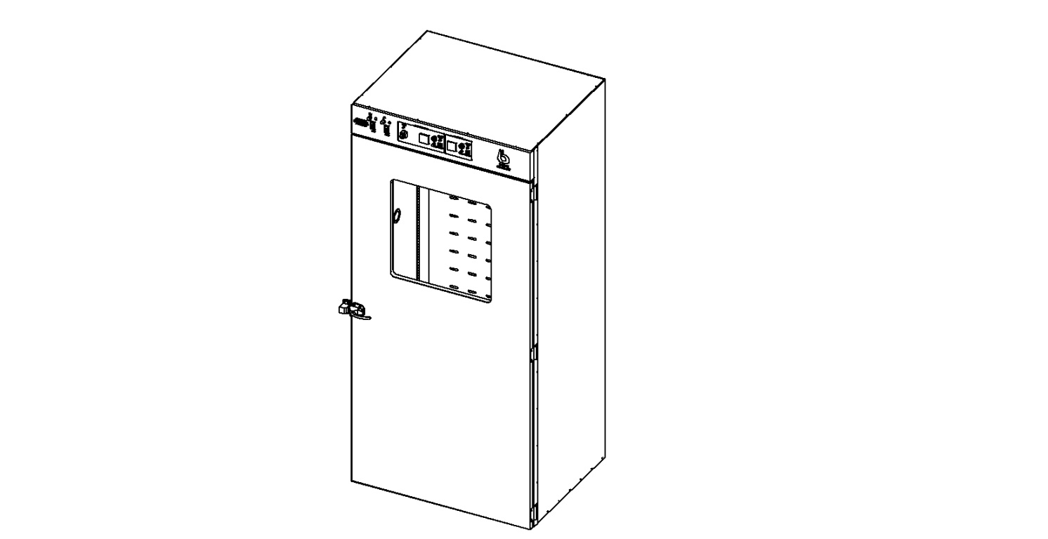

* 115 +/-10VAC, 60 Hz Line Voltage, 15 Amp 115V 60 Hz Average Power Consumption. (Includes 3 amp convenience outlet load)
* Watts: 1500
* Dimensions: exterior: 40″W x 31″D x 86″H (101.6 x 76x 218.4cm)  
  interior: 35″W x 26-5/8”D x 77″H (89 x 67.6 x 195.6cm)
* Volume: 40 cubic ft. (1132 L)
* Temperature Control Range: ambient +9ºC to 50ºC
* Temperature Uniformity: +/-1.0º @ 37°C or better
* CO2 Range: 0-20% Concentration
* Material Construction: Painted 304 stainless steel
* Shipping Weight: 700 lbs approx.
* Environmental Conditions, Operating: indoor use, pollution degree 2, 4º to 50ºC, relative humidity 0-90% non-condensing
* Environmental Conditions, Non-operating: -10º to 60ºC, relative humidity 95% maximum

*\*DISCLAIMER: The information contained in this specification sheet is correct to the best of our knowledge. The recommendations and suggestions therein are made without guarantee or representation as to the results. We recommend that adequate tests be made in your laboratory or plant to determine if this product meets all of your requirements.*

**TECHNICAL SUPPORT**

Technical support is available to all of our customers from inquiry to purchase and through the use of the product. Our service department is dedicated to ensuring the best white glove service to you as possible and to providing quality inspection and review of your concerns, should they arise.

**CUSTOMIZATION**

A lot of items that come out of Bellco Glass, Inc. go through a customization process. A customer will come to us with a specific need. Our engineering department will review the item and its capabilities to do whatever we can to create a custom item to perform exactly how you need it to. Contact us today for your customized quote.

**QUALITY GLASS**

Our manufacturing facility uses Type 1 Class A borosilicate glass. This is a type of glass that is of superior thermal and chemical resistance and specifically designed for volumetric glassware, providing you with products that give you longevity of use.

**Specifications**