# **Bellco Glass, Inc.**

*Biotechnology Manufacturing*

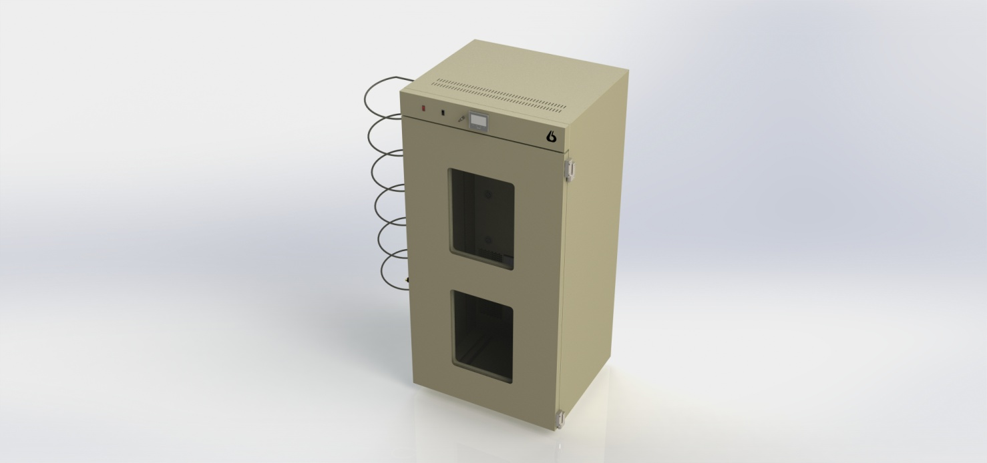

**Bellco Glass, Inc. services available for products and customers:**

* Technical Support
* Customer Service
* Application Support
* Hardware Support
* Sterilization
* Amber coloring
* Plastic coating
* Bellco Incubators have fold out ramps for use with Bellco Roller Apparatus
* 4 interior outlets provide convenience in powering internally placed appliances
* A touchscreen PID temperature controller allows simple setting and monitoring of chamber temperature
* RS485 Communications
* Dual Thermal Pane Windows for viewing

A single fan takes air from the chamber top, passes it over the heater, and re-injects it into the chamber on the back wall

A safety thermostat is included to prevent over-temperature failures

Shelf brackets are included for mounting of optional shelves

**PRODUCT QUALITY**

Bellco Glass, Inc. guarantees quality in each and every product that goes out the door, from start to finish. With our strict QC policies and procedures, you can safely bet that you will get the best products Bellco Glass, Inc. has to offer with every single order.

**OUR VISION**

We will continue to move forward into the future with quality manufacturing, quality raw materials, and constantly redefining and upgrading our internal processes, thus, making us one of the best biotechnology manufacturing companies in the world.

*Bellco Glass, Inc. presents*

**D/W Roll In Incubator, 115V**

SKU: 7728-S0002

# **Bellco Glass, Inc.**

*Biotechnology Manufacturing*

* 115 +/-10VAC, 50/60 Hz Line Voltage, 15 Amp 115V 50 Hz Average Power Consumption. (Includes 3 amp convenience outlet load)
* Watts: 1500
* Dimensions: exterior: 41-5/8″W x 35-5/8″D x 85″H (105.7 x 90.5x 215.9cm)  
  interior: 35-1/2″W x 27-1/4”D x 77″H (90.2 x 69.2 x 195.6cm)
* Volume: 43 cubic ft. (1220 L)
* Temperature Control Range: ambient +9ºC to 50ºC
* Temperature Uniformity: +/-1.0º @ 37°C or better
* Material Construction: Painted cold rolled steel
* Shipping Weight: 700 lbs approx.
* Environmental Conditions, Operating: indoor use, pollution degree 2, 4º to 50ºC, relative humidity 0-90% non-condensing
* Environmental Conditions, Non-operating: -10º to 60ºC, relative humidity 95% maximum

**TECHNICAL SUPPORT**

Technical support is available to all of our customers from inquiry to purchase and through the use of the product. Our service department is dedicated to ensuring the best white glove service to you as possible and to providing quality inspection and review of your concerns, should they arise.

**CUSTOMIZATION**

A lot of items that come out of Bellco Glass, Inc. go through a customization process. A customer will come to us with a specific need. Our engineering department will review the item and its capabilities to do whatever we can to create a custom item to perform exactly how you need it to. Contact us today for your customized quote.

**QUALITY GLASS**

Our manufacturing facility uses Type 1 Class A borosilicate glass. This is a type of glass that is of superior thermal and chemical resistance and specifically designed for volumetric glassware, providing you with products that give you longevity of use.

**Specifications**

*\*DISCLAIMER: The information contained in this specification sheet is correct to the best of our knowledge. The recommendations and suggestions therein are made without guarantee or representation as to the results. We recommend that adequate tests be made in your laboratory or plant to determine if this product meets all of your requirements.*