# **Bellco Glass, Inc.**

*Equipment and Glassware Manufacturing*

*\*DISCLAIMER :The information contained in this specification sheet is correct to the best of our knowledge. The recommendations and suggestions therein are made without guarantee or representation as to the results. We recommend that adequate tests be made in your laboratory or plant to determine if this product meets all of your requirements.*

**Bellco Glass, Inc. services available for products and customers:**

* Technical Support
* Customer Service
* Application Support
* Hardware Support

**FEATURES**

Brushless DC Motor/Motor Controller

LCD Digital Display

Low Profile Aluminum Chassis

On/Off Rocker Switch

Stainless Steel Cover

Non-slip Timing Belts

Heavy Duty Magnetic Drive Plate

In-Line Power Supply

CE Compliant

Optional Motion Alarm (Factory Installed Only)

**PRODUCT QUALITY**

Bellco Glass, Inc. guarantees quality in each and every product that goes out the door, from start to finish. With our strict QC policies and procedures, you can safely bet that you will get the best products Bellco Glass, Inc. has to offer with every single order.

**OUR VISION**

We will continue to move forward into the future with quality manufacturing, quality raw materials, and constantly redefining and upgrading our internal processes, thus, making us one of the best biotechnology manufacturing companies in the world.

*Bellco Glass, Inc. presents*

**1 Position Digital Stir Comp, 230V**

SKU : 7785-D1236

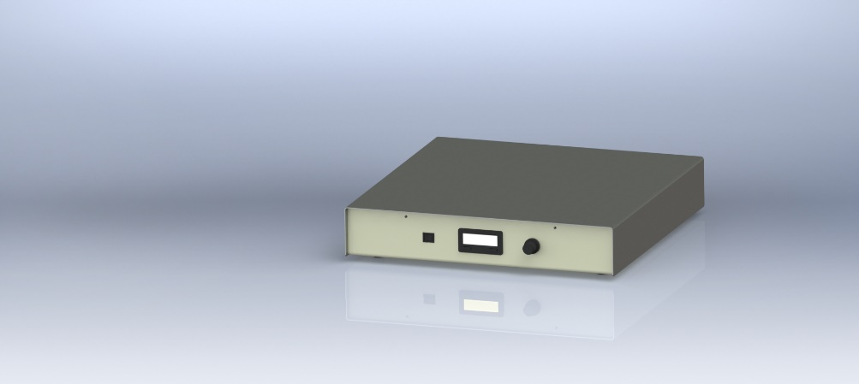

* Bell-ennium™ Magnetic Stirrer, benchtop model
* Electrical rating: 230VAC/24VDC fused at 1 amp
* Max flask size: 36L
* Speed range: 30-500 RPM +/- 2%
* Dimensions: 18”W x 20”D x 3 3/8”H (45 X 50 X 8.5 cm)
* Weight: 16.5 lb (7.5 kg)
* Power Consumption: 13 Watts